Discussion 8 Module-8: Virtualization and Distributed File Systems
In today's network environment, virtual machines (VMs) or virtualization play a substantial role by proving a wide range of benefits. Such as Efficient Resource Utilization, Security and Isolation, Ideal for Development and Testing, Disaster Recovery, Scalability and Flexibility, Support for Legacy Applications, and Cloud Compatibility.
Before I discuss the benefits of offers by virtualization, I would like to define it in the context of today's network environment.
Virtualization (VM) is a technology that allows system hardware to be shared between multiple virtual environments (Amazon, n.d.). In other words, hardware can be shared by multiple virtual machines, allowing these machines to operate simultaneously on a physical system. In today's network environment is mostly related to server virtualization but is not limited to it, it can also refer to the virtualization of network equipment such as routers and switches, and personal computers. For example, you can rent a gaming pc with your desired specs on a cloud base service like Google Stadia, Nvidia's GeForce Now, or Microsoft's xCloud, allowing you to enjoy high-performance gaming without the need for owning hardware.
Additionally, most modern application stacks (or tech stack) are developed to work over a network (LAN, WAN, Cloud). “An application stack is simply a combination of technologies (programming languages, libraries, tools, and services) that are used together to build, deploy, and maintain an application” (D3V Technology Solutions, 2021). Modern application stacks can be deployed using three different technologies, Bare Metal, Virtual Machines, and Containers (ByteByteGo, 2022). To understand the benefit provided by VM in today's network environment, it is important to understand the difference between Bare Metal, VM, and Containers.
Figure 1 depicts bare metal, virtualized, and containerized systems.
Figure 1
Bare metal, VMs, and containers
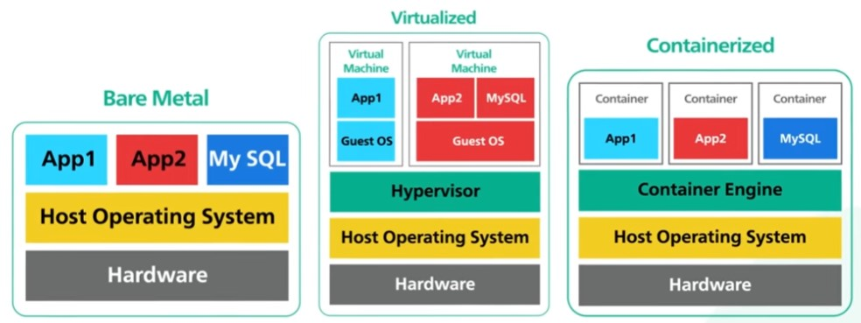
Note. From Big misconceptions about bare metal, virtual machines, and containers, by ByteByteGo, 2021, (https://www.youtube.com/watch?v=Jz8Gs4UHTO8&amp;t=11s.). Copyright 2023 by yuotube.com.
- Bare Metal is not to be confused with bare metal hypervisor. It is just a physical computer that is a single tenant only. All servers used to be bare metal. Bare metal gives complete control over the hardware resources. The advantages are the highest performance from the hardware and isolation. Isolation provides security, and it is a solution to the noisy neighbor problem. The noisy neighbor problem occurs when one tenant's performance is impacted because of the activities of another tenant sharing the same hardware. The downsides are cost, hard to manage, and hard to scale. (ByteByteGo, 2022)
- VM allows for multiple operating systems to run on a single physical (bare metal) server through the use of a hypervisor, a software layer that abstracts the hardware. Each VM has its own guest operating system and applications. Some systems employ a bare metal hypervisor that directly controls the hardware, offering enhanced performance but requiring more expensive supporting hardware. Additionally, VMs provide benefits such as cost-efficiency, as many VMs can run on the same hardware. They are also scalable, and sophisticated software can even transfer a running VM from one physical server to another without shutting down the VM. However, VMs can be affected by the "noisy neighbor" problem, where a VM's performance suffers due to high resource usage by another VM on the same hardware. VMs also have security risks, such as side-channel attacks like Meltdown and Spectre. (ByteByteGo, 2022)
- Containers are a lightweight form of virtualization that encapsulates an application along with its dependencies, enabling it to run anywhere. Rather than using a hypervisor to virtualize hardware, containers virtualize the operating system via a container engine that oversees many containers, and each container operates as an independent environment. Containers offer several advantages: they're faster to provision resources, more scalable, and more portable. They're also lightweight, allowing a bare metal server to host more containers than VMs. Because they run as native processes of the host operating system, they also start more quickly. However, containers have potential security drawbacks. They all share the same operating system. This exposes them to a broader class of security vulnerabilities at the OS level. (ByteByteGo, 2022)
Below is a more specific list of VM’s benefits in today's network environment.
- Efficient Resource Utilization: By allowing multiple VMs to run on a single physical system, organizations can make optimal use of their hardware resources. This improves efficiency and cost savings.
- Security and Isolation: VMs operate in isolation from one another, even when running on the same physical host. For example, if a VM encounters an issue, such as a system crash or a security breach, the problem is confined to that VM and doesn't impact the others.
- Ideal for Development and Testing: VMs offer an excellent environment for testing and development. They can be created, used, and deleted without any impact on the primary operating system.
- Disaster Recovery: VMs can be easily replicated and restored in the event of a disaster. They can also be migrated between different physical machines or locations, providing support for business continuity and disaster recovery.
- Scalability and Flexibility: VMs are easy to create, delete, or migrate, they allow for a highly flexible and scalable IT infrastructure.
- Support for Legacy Applications: VMs can run various operating systems, which makes them ideal for running older applications that may not be compatible with newer systems.
- Cloud Compatibility: As the fundamental building blocks of cloud environments, VMs play a critical role in the migration of workloads to the cloud, facilitating a range of benefits, including scalability and cost.
Ref: Carklin (2021) and Sheldon & Kirsch (2023)
Finally, VM plays an essential role in today's network environment. They ensure efficient utilization of resources, they provide enhanced security and isolation, they are ideal for development and testing, they allow disaster recovery, they are flexible and scalable, they provide support for legacy application, and they are cloud compatible.
-Alex
References:
Amazon. (n.d.). What is virtualization? Amazon.com. https://aws.amazon.com/what-is/virtualization/#:~:text=Virtualization%20is%20a%20process%20that,%2C%20processing%20power%2C%20and%20storage.
Carklin, N. (2021, June 1). What are the benefits of virtual machines?. Parallels Remote Application Server Blog - Application virtualization, mobility and VDI. https://www.parallels.com/blogs/ras/benefits-virtual-machines/

ByteByteGo. (2022, July 14). Big misconceptions about bare metal, virtual machines, and containers [Video][Figure 1]. YouTube. https://www.youtube.com/watch?v=Jz8Gs4UHTO8&amp;t=11s
D3V Technology Solutions (2021, November 24). How to achieve a modernized APP STACK: Cloud insights. D3vtech.com. https://www.d3vtech.com/insights/how-to-achieve-a-modernized-app-stack#:~:text=An%20app%20stack%20(or%20tech,characteristics)%20of%20the%20ideal%20architecture.
Sheldon, R., & Kirsch, B. (2023, May 1). What is a virtual machine and how does it work?. IT Operations. https://www.techtarget.com/searchitoperations/definition/virtual-machine-VM?Offer=abt_pubpro_AI-Insider

